**Charmouth Primary School Round-up**

**Friday 24th November 2023**

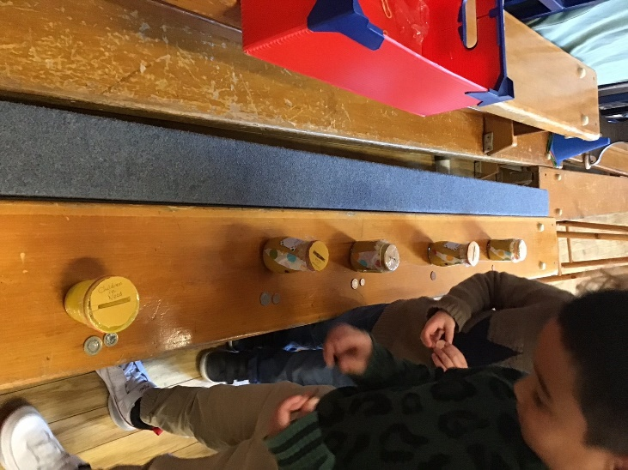

**Diary Dates**

**Friday 24th November**

PTFA Christmas Fair – 3:30-5:15pm

**Monday 27th November**

Pantomime – Beauty and the Beast

**Tuesday 5th and Wednesday 6th December**

Nativity @ 2:30pm

**Wednesday 13th December**

Christmas Meal

**Friday 15th December – 2:30pm**

Carol concert @St Andrews Church

**Friday 15th December**

Last Day of Term

**Thursday 4th January 2024**

First Day Back

**Children in Need**

Thank you to everyone who brought in coins to decorate our ammonite. We raised an amazing £82.87 and had a lot of fun – Early Years sorted the coins into groups and Navigators counted the total.

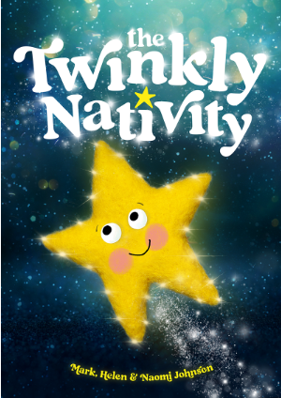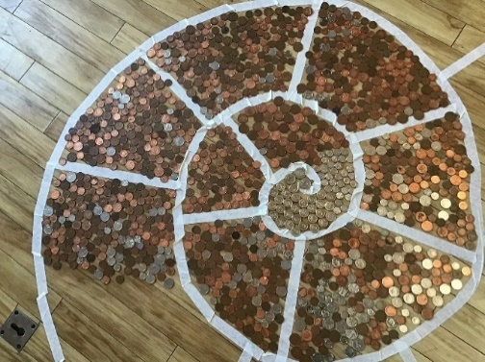

**Pathfinders**

Everyone should have received a letter informing them of what their child is in the play and what they need to provide in terms of costumes. If anyone has any questions, please come and ask one of the Explorers or Pathfinders members of staff (ideally Mrs McDonald!). Please could costumes be in by next Thursday 30th November. Thank you.

**Nativity**

Please note the Nativity will be on Tuesday 5th and Wednesday 6th December at 2:30pm.

Tickets are available from the school office.

We will be asking for a voluntary contribution on the performance days.

**Christmas Carol Concert**

Our Carol Concert will take place on Friday 15th December at 2pm at St Andrews Church in Charmouth.

All are welcome.

**Lunches and Snacks**

Please can we ask that you do your best to provide a healthy and nutritious snack (KS2) and lunch for your children.

Eating and lifestyle habits are established early in life.

It is important that you try and limit the number of times a day that your child has sugary foods and drinks. The risk of developing tooth decay increases as the amount and frequency of sugars intake rises. Soft drinks such as carbonated drinks and squashes, and fruit juices can be high in free sugars which can be harmful to teeth.

Please do not send your child into school with carbonated or sugary drinks.

May we also remind you that we are a nut-free school. Please do not send your child in with any nuts in their lunch or snacks.

**Meet Father Christmas at Lyme Regis Museum**

On 2nd December Lyme Regis Museum will be welcoming a very special visitor as Father Christmas takes some time out of his very busy schedule to meet and greet our visitors! There will also be a carousel of Christmas activities to enjoy, including a family-friendly Christmas Bunting Craft Workshop and a Christmas Mouse Trail. A festive day of fun for all the family... don't miss it!

2nd December, 10am-12pm & 2-4pm (drop-in)

FREE with Museum Admission/Annual Pass

**Head Lice**

Please be aware that there are several cases of head lice in school.

Whilst lice are nothing more than a nuisance, it is important that children are checked on a weekly basis so that any head lice can be dealt with quickly and before they are allowed to spread.

Further advice on the treatment of head lice can be found on the NHS website. http:/www.nhs.uk/conditions/head-lice

**Car Park Safety**

Please **do not** use or park in the car park at drop off/pick up unless you have permission from the school office

If you do need to use the car park as a one off, please contact us so we are aware and can support you with this.

Please ensure you **walk on the path** and **not through the car park**.

Parents and carers are permitted to park in the car park if picking up for an after-school club.

If exiting the car park via car, please do so slowly as we have had several near misses recently.

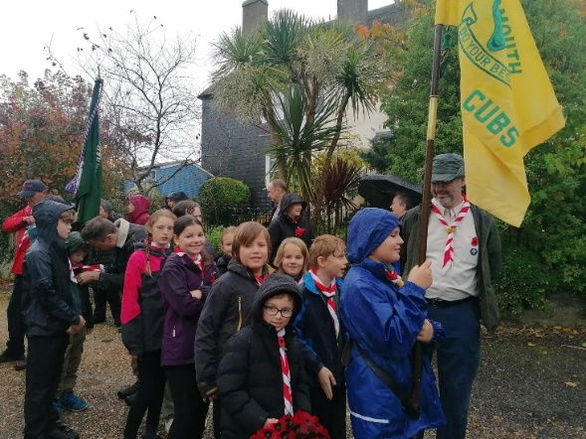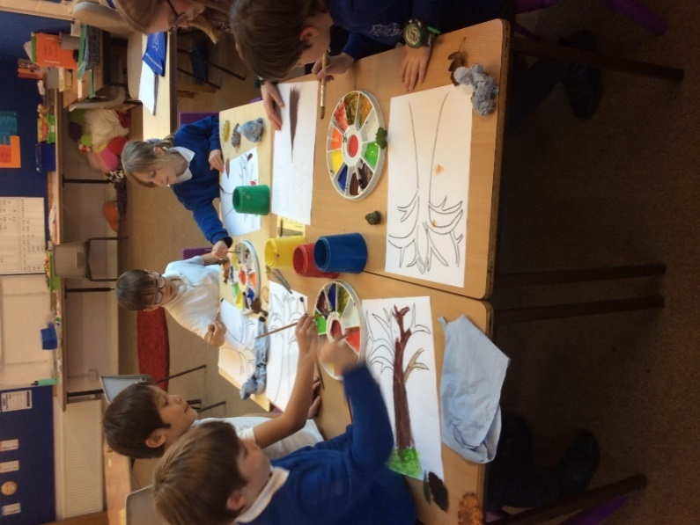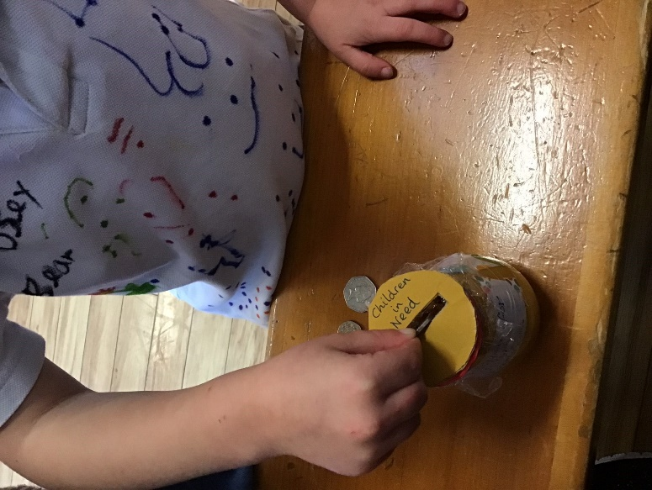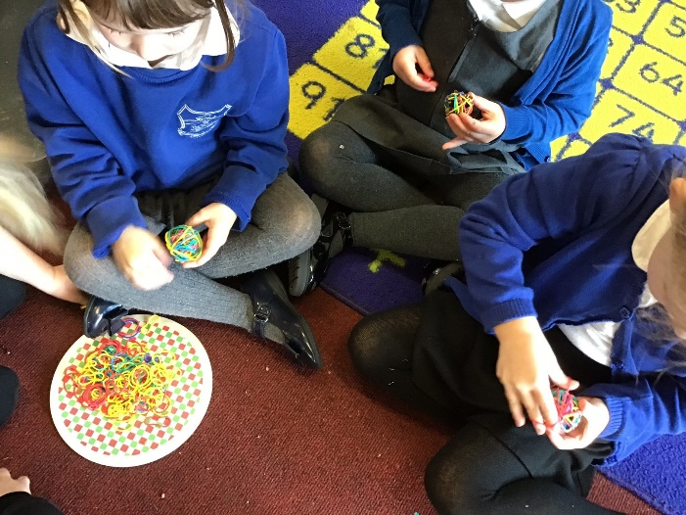

**Remembrance Sunday**

Well done to all those who took part with great respect in the Remembrance Sunday Parade.

**Explorers**

Explorers have been practising their fine motor skills in lots of ways, including with brightly coloured bands and the coins from Children in Need.

**Attachments**

There are several attachments with this newsletter:

* Support for inter-parental conflict – a project to improve parents’ relationships.
* Lyme Regis Museum Father Christmas flyer
* New to You Sale in Bridport
* Charmouth Pantomime
* Teach Your Monster Phonics Game

**Autumn Colours**

After showing an interest in the autumnal colours in the environment, some children collected leaves and used these as inspiration to design and paint their own autumn trees.

**Every Minute Counts**

If your child arrives late to school every day, their learning begins to suffer and this usually impacts upon the subject area that is the first lesson of the day – in our school this is usually phonics/reading/grammar or maths. Below is a graph showing how being late to school every day over a school year adds up to lost learning time.

**Parent Questionnaire**

*‘My child is flourishing at Charmouth Primary School.’ (Parent Questionnaire November 2023)*

Thank you to all those parents who completed the parent questionnaire as part of our parent consultations. Reviewing the responses of this and previous surveys, shows that our work is positively impacting on the day to day experience of our children and the views of their parents. It is great to hear that you recognise the renewed focus on outdoor learning opportunities and that you are finding the weekly learning update sheets helpful. Points to develop were very much raised individually and will be reflected on within the wider context.

As part of the survey, we also asked about wrap around care. Over 60% of those who would use before or after school provision would do so on an ad hoc basis, this makes it very difficult to make viable. We would, however, like further information from anyone who would use before and/or after school provision to see whether it is something we can make feasible, even if only on limited days. Therefore, we would ask that you complete the survey using the following link to help us try to plan around your needs: <https://forms.office.com/e/vxkq3N8Fbd>